Hermes
User Manual
Draft 1
April 26, 2004
Slippery Rock University
Yai Oladokun Laleye yol6231@sru.edu
Michael McNamera mlm7800@sru.edu
Anthony Pitluga alp5228@sru.edu

Contents
1 Hermes System v 2.3 1
1.1 Master Server 1
1.1.1 Setting Up In Jbuilder7 1
1.1.2 Setting Up in Command Line 5
1.1.3 Running 5
1.2 Shipper Agent 7
1.2.1 Setting Up in JBuilder 7 7
1.2.2 Setting Up in Command Line 10
1.2.3 Running 10
1.3 Carrier Agent 12
1.3.1 Setting Up in JBuilder 7 12
1.3.2 Setting Up in Command Line 16
1.3.3 Running 16
1.4 Master Schedule Reports 20
1.4.1 Detailed Solution 20
1.4.2 Short Solution 28
2 Automation Configuration 30
2.1 Introduction 30
2.2 The User Interface 30
2.3 Creating a New Problem Configuration 31
2.4 Opening a Previously Saved Problem Set 33
2.5 Editing Existing Problems in a Problem Set 34
2.6 Deleting a Problem from the Problem Set 35
2.7 Running a Problem Set 35

Hermes System v 2.3
This section contains the user manuals for the various user interfaces in the Hermes System.
This program implements Greedy Randomized Heuristic for vehicle routing with time windows using a java agent system and Socket communication.

There are three kinds of agents that can be created:
Master Server Agent – keeps track of all the agents registered in the system (by recording their name, code and port number in the access database (dsn:” E-RegisterShipCarr”, file: “RegisterShipperCarrier.mdb”); provides communication between Shipper Agent and Carrier Agents registered in the system; is able to auction customer point data; provides data on solution for total demand of route, total distance traveled, total travel time, total tardiness, total excess time, total overload, total number of customers and trucks, and total wait time.

Shipper Agent – has the capability to read the input data for the set of customers from the input file; is able to send messages to the Master Server and to Carriers via the Master Server; keeps track of the number of bids for each customer point, and when the number of bids for a particular point becomes equal to the number of Carrier Agents registered in the system it sends the point customer information to the bidder with the lowest insertion cost.

Carrier Agent – has an instance of the Zeus system for storing customers; has indirect access to greedy randomized heuristic with time windows algorithm to calculate cost for a particular customer; able to send messages to Master Server and Shipper Agent via the Master Server; shows the total demand of route, total distance traveled, total travel time, total tardiness, total excess time, total overload, total number of customers and trucks, and total wait time; provides graphic representation of the route; provides option to optimize route for individual carriers.

Assumptions made:
The problem data files and database files have been formatted correctly and provided to the user.

Master Server

Setting Up In Jbuilder7
- Open the Hermes System project file in JBuilder7.
- Create a runtime environment.
  - Open the Run menu.
  - Choose the Configurations option.
    - A dialog will open to help create the configuration.
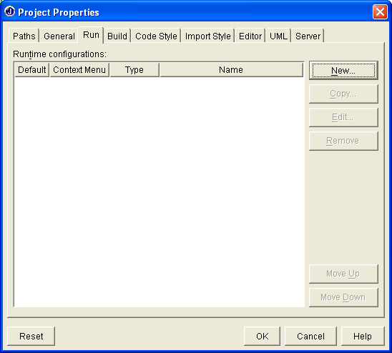

  - Click the New button.
    - Enter the name of the Agent in the Configuration name text field (suggested: Master Agent).
    - Click the ellipses button.
      - Navigate into the Hermes package.
      - Select the class named Master.
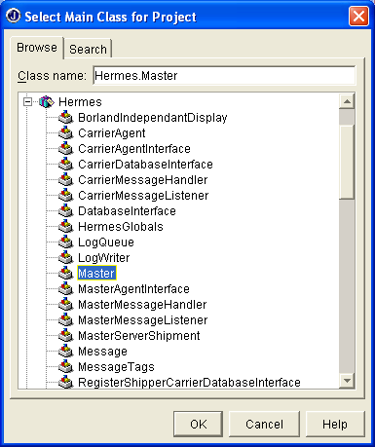
      - Click OK.
    - Hermes.Master should be displayed in the Main class text field.
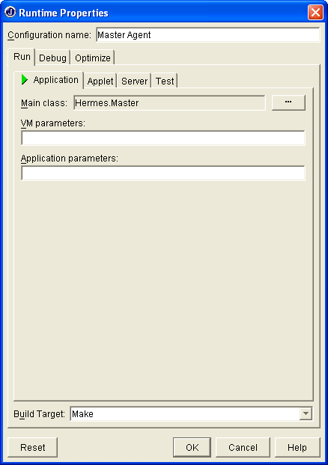
    - Click OK.
  - The Master Agent configuration should be listed in the window.
  - Click OK.
- Start the Master Server.
  - Choose one of three ways to start the application.
    - Click on the Run Project button in the tool bar.
    - Open the Run menu and select the Run Project option.
    - Press the F9 key on the keyboard.
  - If this is the only application with a runtime configuration defined, then the Master Server window will be displayed.
    - Otherwise, select the Master Server option in the list provided.
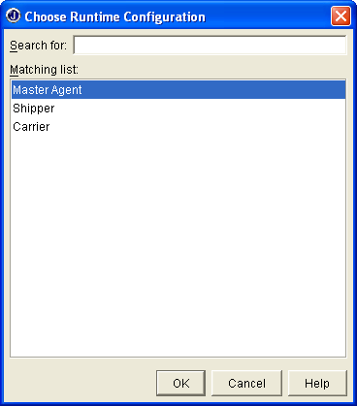

Setting Up in Command Line
- Open a command window (recommended: cmd.exe).
- Start the Master Server.
  - On the command line, type: java Hermes.Master
  - Press the enter key.

Running
- The Master Server is relatively non-functional until the initial solution is found.
  - The only service the Master Server can perform is terminating the auctioning system, please see I.5 for details.
- When the initial solution is found, the Master Server window will be updated with values corresponding to their respective labels.
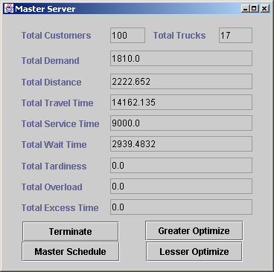
- There are two ways to optimize the solution.
  - Lesser Optimize.
    - Optimizes the schedules of each individual carrier agent at once.
    - Optimizations occur only within each individual carrier agent.
  - Greater Optimize.
    - Optimizes the schedules between the carrier agents.
    - Carrier agents will communicate with each other, through the Master Server, swapping shipments to get a better solution.
- To print the solution files for analysis, click the Master Schedule button.
  - This generates two solution files. [see section 2.1.4 for report mock up and explanation about values given]
    - Detailed solution.
      - The detailed solution file uses the problem file’s name as a prefix concatenated with the label detailSolution (i.e. c101_detailSolution.txt).
      - This file contains detailed information about the solution, listing statistics about each depot, each truck within the depots, and each shipment scheduled for the trucks.
    - Short solution.
      - The short solution file uses the problem file’s name as a prefix concatenated with the label shortSolution (i.e. c101_shortSolution.txt).
      - The short solution file lists general information about the solution, such as overall totals, depot numbers with truck numbers and shipment indexes within the trucks.
- To terminate the application and all agents registered with the Master Server, Click the Terminate button.

Shipper Agent

Setting Up in JBuilder 7
- Open the Hermes System project file in JBuilder7.
- Create a runtime environment.
  - Open the Run menu.
  - Choose the Configurations option.
    - A dialog will open to help create the configuration.
  - Click the New button.
    - Enter the name of the Agent in the Configuration name text field (suggested: Shipper Agent).
    - Click the ellipses button.
      - Navigate into the Hermes package.
      - Select the class named ShipperAgent.
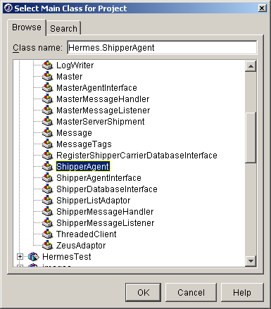
      - Click OK.
    - Hermes. ShipperAgent should be displayed in the Main class text field.
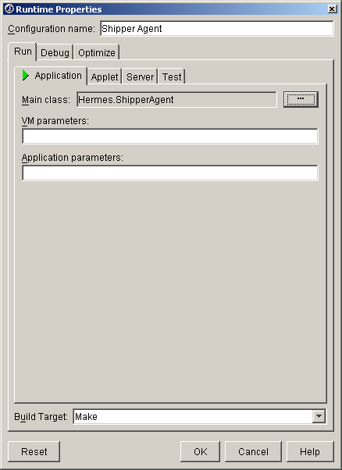
    - Click OK.
  - The Shipper Agent configuration should be listed in the window.
  - Click OK.
- Start the Shipper Agent.
  - Choose one of three ways to start the application.
    - Click on the Run Project button in the tool bar.
    - Open the Run menu and select the Run Project option.
    - Press the F9 key on the keyboard.
  - If this is the only application with a runtime configuration defined, then the Shipper Agent window will be displayed.
    - Otherwise, select the Shipper Agent option in the list provided.

Setting Up in Command Line
- Open a command window (recommended: cmd.exe)
- Start the Shipper Agent.
  - On the command line, type: java Hermes.ShipperAgent
  - Press the enter key.

Running
- Register the agent with the Master Server by clicking the Register button.
  - Please note that a Master Server must be started before this service will work, otherwise the system will generate an error and shutdown.
  - If the Shipper name and Shipper code are not already displayed in the corresponding text fields of the Shipper Agent window, enter them before registering the agent.
  - If the Shipper Agent is running on a different machine than the Master Server, then the Master Server’s IP address and port number must be given.
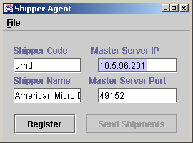
    - Enter the Master Server’s IP address in the Master Server IP text field.
    - Enter the Master Server’s port number in the Master Server port text field.
  - After the Agent is registered, the register button will be disabled.
- Read the problem data file.
  - Select the File menu.
  - Click the Open option to open the file dialog.
  - Navigate to the problem file, select it and click the open button in the file dialog.
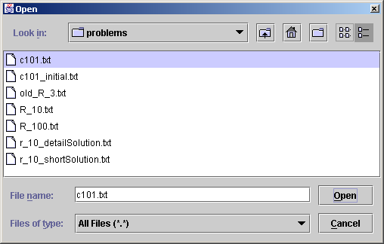
- Send the customer point data to the Master Server for the auctioning to take place by clicking the Send Customers button. This may take a few minutes.
  - Please note that at least one Carrier Agent must be registered with the Master Server for a successful auction.
- To close an agent click on the close box in the window title bar of the agent or select the Exit option in the file menu.

Carrier Agent

Setting Up in JBuilder 7
- Open the Hermes System project file in JBuilder7
- Create a runtime environment.
  - Open the Run menu.
  - Choose the Configurations option.
    - A dialog will open to help create the configuration.
  - Click the New button.
    - Enter the name of the Agent in the Configuration name text field (suggested: Carrier Agent).
    - Click the ellipses button.
      - Navigate into the Hermes package.
      - Select the class named CarrierAgent.
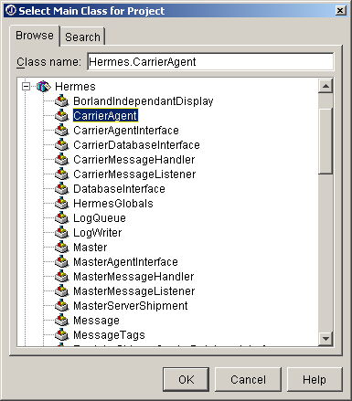
      - Click OK.
    - Hermes. CarrierAgent should be displayed in the Main class text field.
    - Enter the name of the file containing the depot information in the Application parameters text field.
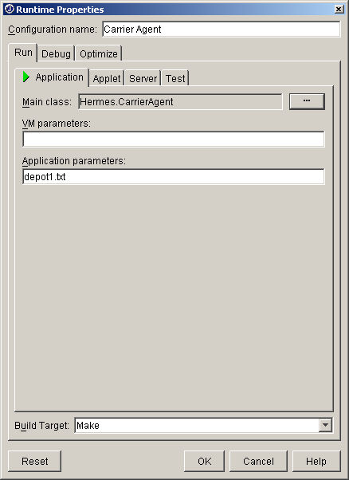
    - Click OK.
  - The Carrier Agent configuration should be listed in the window.
  - Click OK.
- Start the Carrier Agent.
  - Choose one of three ways to start the application.
    - Click on the Run Project button in the tool bar.
    - Open the Run menu and select the Run Project option.
    - Press the F9 key on the keyboard.
  - If this is the only application with a runtime configuration defined, then the Carrier Agent window will be displayed.
    - Otherwise, select the Carrier Agent option in the list provided.
  - If more than one carrier agent is to run on the same machine with different depot information:
    - After starting the one carrier agent, edit the runtime configuration for the Carrier Agent and change the Application parameters text field to contain the necessary depot file name.
    - Or create multiple Carrier Agent configurations, each with their own necessary depot file names entered for the Application parameter text field, and with configuration names appropriately distinguishing the agents from each other.
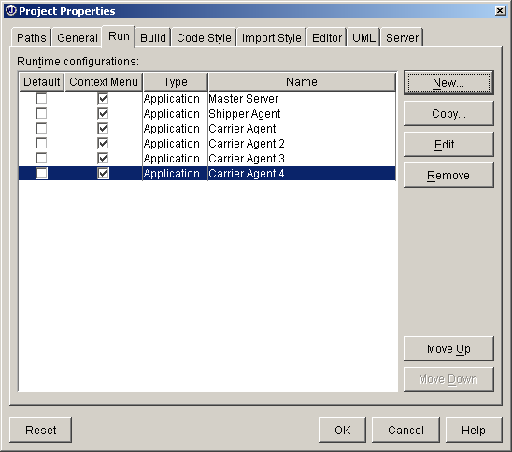

Setting Up in Command Line
- Open a command window (recommended: cmd.exe).
- Start the Carrier Agent.
  - On the command line, type: java Hermes.CarrierAgent <name of depot information file>
  - Press the enter key.

Running
- Register the agent with the Master Server by clicking the Register button.
  - Please note that a Master Server must be started before this service will work, otherwise the system will generate an error and shutdown.
  - If the Carrier name and Carrier code are not already displayed in the corresponding text fields of the Carrier Agent window, enter them before registering the agent.
  - If the Carrier Agent is running on a different machine than the Master Server, then the Master Server’s IP address and port number must be given.
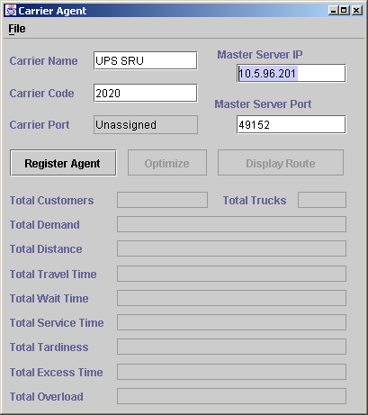
    - Enter the Master Server’s IP address in the Master Server IP text field.
    - Enter the Master Server’s port number in the Master Server port text field.
  - After the Agent is registered, its port number will be displayed to uniquely identify itself and the register button will be disabled.
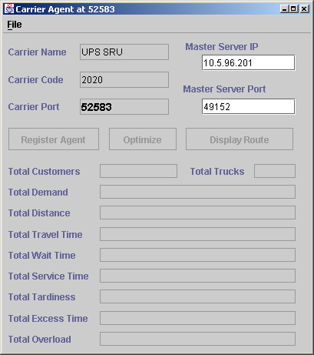
- The Carrier Agent is relatively non-functional until the initial solution is found.
  - The only service the Carrier Agent can perform is terminating itself by clicking the close box or selecting the Exit option in the File menu.
- As the initial solution is found, the Carrier Agent window will be dynamically updated with values corresponding to their respective labels.
  - When the solution is finished, the Carrier Agents buttons will be enabled
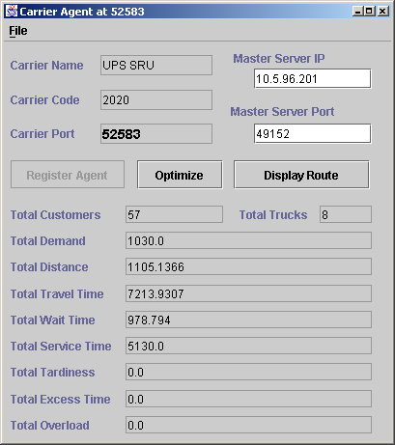
- To optimize the Carrier Agent’s schedule, click the Optimize button.
  - This will run a series of optimizations on the Carrier Agents schedule without communicating with other agents.
  - When the optimization is finished, the Master Server will be updated to reflect the results.
- To graphically display the Agent’s schedule as a route, click the Display Route button.
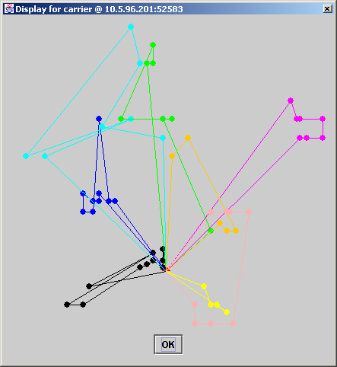
  - This will create a separate window with vertices representing the shipments within a certain schedule and colored lines representing a truck route connecting the vertices. Each route will be represented in a different color for clarity.
  - The point in which all the routes seem to emanate from is the position of the depot.
- To close an agent click on the close box in the window title bar of the agent or select the Exit option in the file menu.

Master Schedule Reports

Detailed Solution
The detailed solution file is comprised of three parts: general solution information about the entire schedule, depot solution information about each depot and truck in the schedule, and shipment solution information about each shipment in the schedule.

- General solution information.
  - Starts with the absolute path to the problem file.
  - Number of shipping agents used in the auctioning system.
  - Number of carrier agents used in the auctioning system.
  - Maximum capacity of the trucks for the schedule.
  - Maximum distance the trucks could travel.
  - The total amount of travel time for all trucks in the schedule.
  - The total distance covered by all trucks in the schedule.
  - The total amount of service time spent by all trucks in the schedule.
  - The total amount of time spent waiting to service shipments for all trucks in the schedule.
  - The total amount of tardiness time for all trucks in the schedule.
  - The total amount of time exceeding the limit for all trucks in the schedule.
  - The total amount of demand hauled by all trucks in the schedule over the capacity limit.
- Depot solution information.
  - Depot index number and position coordinates of the depot.
    - Index number of the first truck in the depot.
    - Maximum duration for the truck.
    - Maximum capacity for the truck.
    - Demand the truck is currently hauling along with the distance the truck traveled.
    - Number of shipments serviced by the truck.
    - Total time the truck spent waiting to service the shipments.
    - Total time the truck spent traveling.
    - Total time the truck spent servicing shipments.
    - Total distance the truck traveled.
    - Total amount of time the truck was tardy to a shipment.
    - Total time the truck exceeded its maximum duration.
    - Amount of demand the truck is carrying over its capacity limit.
  - The shipment solution information is given for this truck followed by the information for the next truck in the depot, etc…until all trucks are accounted for in this depot.
  - The information for the next depot will then be given in the same fashion.
- Shipment solution information.
  - The total number of shipments for a certain truck (including trips to the depot).
  - Index of the first shipment (always zero since it is the depot at the start).
    - Index of the depot.
    - X-coordinate of the depot.
    - Y-coordinate of the depot.
    - Maximum duration of the trucks in this depot.
    - Maximum capacity of the trucks in this depot.
  - Index of the next shipment.
    - X-coordinate of the shipment.
    - Y-coordinate of the shipment.
    - Earliest time to service the shipment.
    - Latest time to service the shipment.
    - The time the truck spent waiting to service this shipment.
    - The time the truck arrived at this shipment site.
    - The latest possible time to arrive at this shipment and still be able to service the rest of the schedule feasibly.
    - Time needed to service this shipment.
    - Distance to the next shipment.
    - Amount of demand this shipment will require the truck to haul.
    - Capacity of the truck when it arrived at the shipment.
    - Capacity of the truck when it leaves the shipment.
  - The description of part 3.c is the same for all shipment within the truck schedule.
  - Index of the first shipment (always negative one since it is the depot at the end).
    - Index of the depot.
    - X-coordinate of the depot.
    - Y-coordinate of the depot.
    - Maximum duration of the trucks in this depot.
    - Maximum capacity of the trucks in this depot.
- Example:

VRPTW File : c:\documents and settings\mlm7800\desktop\hermes\problems\r_10.txt
No. of Shippers : 1
No. of Shipments : 10
No. of Carriers : 1
Maximum Capacity : 200.0
Maximum Distance : 230.0
********************************************
Over all Travel Time ========= 1041.4818
Over all Distance covered === 89.79939
Over all Service Time ======== 900.0
Over all Wait Time =========== 51.682465
Over all Tardiness Time ====== 0.0
Over all Excess Time ========= 0.0
Over all Overload =========== 0.0
********************************************
Depot No. and vertices are: 1 35.0 35.0
Truck number: 0
Maximum duration: 230
Maximum capacity: 200
Current Demand: 150.0 Current Duration: 89.79939
Current No. of Shipments: 10
totalWaitTime 51.682464599609375
TravelTime 1041.4818115234375
totalServiceTime 900.0
totalDistance covered 89.79939270019531
totalTardinessTime 0.0
totalExcessTime 0.0
totalOverload 0.0
Total local 1-Opts 0
Total local 2-Opts 0
Total local 3-Opts 0
Total number of cells: 12
Cell Index : 0
Depot Number : 1
X coordinate : 35.0
Y coordinate : 35.0
Max distance : 230
Max capacity : 200

Cell Index : 5
X coordinate : 42.0
Y coordinate : 65.0
Earliest Time : 15.0
Latest Time : 67.0
Wait Time : 0.0
Arrival Time : 30.805843
Latest Arrival: 40.56601
Service Time : 90.0
Distance to next: 1.0
demand : 10.0
AC : 200.0
DC : 190.0

Cell Index : 3
X coordinate : 42.0
Y coordinate : 66.0
Earliest Time : 65.0
Latest Time : 146.0
Wait Time : 0.0
Arrival Time : 121.80585
Latest Arrival: 131.56601
Service Time : 90.0
Distance to next: 2.0
demand : 10.0
AC : 190.0
DC : 180.0

Cell Index : 7
X coordinate : 40.0
Y coordinate : 66.0
Earliest Time : 170.0
Latest Time : 225.0
Wait Time : 0.0
Arrival Time : 213.80585
Latest Arrival: 223.56601
Service Time : 90.0
Distance to next: 2.828427
demand : 20.0
AC : 180.0
DC : 160.0

Cell Index : 8
X coordinate : 38.0
Y coordinate : 68.0
Earliest Time : 255.0
Latest Time : 324.0
Wait Time : 0.0
Arrival Time : 306.63428
Latest Arrival: 316.39444
Service Time : 90.0
Distance to next: 3.6055512
demand : 20.0
AC : 160.0
DC : 140.0

Cell Index : 10
X coordinate : 35.0
Y coordinate : 66.0
Earliest Time : 357.0
Latest Time : 410.0
Wait Time : 0.0
Arrival Time : 400.23984
Latest Arrival: 410.0
Service Time : 90.0
Distance to next: 5.0
demand : 10.0
AC : 140.0
DC : 130.0

Cell Index : 9
X coordinate : 38.0
Y coordinate : 70.0
Earliest Time : 534.0
Latest Time : 605.0
Wait Time : 38.760162
Arrival Time : 495.23984
Latest Arrival: 591.9223
Service Time : 90.0
Distance to next: 2.236068
demand : 10.0
AC : 130.0
DC : 120.0

Cell Index : 6
X coordinate : 40.0
Y coordinate : 69.0
Earliest Time : 621.0
Latest Time : 702.0
Wait Time : 0.0
Arrival Time : 626.2361
Latest Arrival: 684.1584
Service Time : 90.0
Distance to next: 2.236068
demand : 20.0
AC : 120.0
DC : 100.0

Cell Index : 4
X coordinate : 42.0
Y coordinate : 68.0
Earliest Time : 727.0
Latest Time : 782.0
Wait Time : 8.527832
Arrival Time : 718.47217
Latest Arrival: 776.3945
Service Time : 90.0
Distance to next: 3.6055512
demand : 10.0
AC : 100.0
DC : 90.0

Cell Index : 2
X coordinate : 45.0
Y coordinate : 70.0
Earliest Time : 825.0
Latest Time : 870.0
Wait Time : 4.39447
Arrival Time : 820.6055
Latest Arrival: 870.0
Service Time : 90.0
Distance to next: 2.0
demand : 30.0
AC : 90.0
DC : 60.0

Cell Index : 1
X coordinate : 45.0
Y coordinate : 68.0
Earliest Time : 912.0
Latest Time : 967.0
Wait Time : 0.0
Arrival Time : 917.0
Latest Arrival: 967.0
Service Time : 90.0
Distance to next: 34.48188
demand : 10.0
AC : 60.0
DC : 50.0

Cell Index : -1
Depot Number : 1
X coordinate : 35.0
Y coordinate : 35.0
Max distance : 230
Max capacity : 200

Short Solution
The short solution file is comprised of two parts: general solution information about the entire schedule, depot solution information about each depot and truck in the schedule.

- General solution information.
  - Starts with the absolute path to the problem file.
  - Number of shipping agents used in the auctioning system.
  - Number of shipments auctioned in the system.
  - Number of carrier agents used in the auctioning system.
  - Maximum capacity of the trucks for the schedule.
  - Maximum distance the trucks could travel.
  - The total amount of demand the trucks hauled for the schedule.
  - The total amount of time spent waiting to service shipments for all trucks in the schedule.
  - The total amount of travel time for all trucks in the schedule.
  - The total amount of service time spent by all trucks in the schedule.
  - The total distance covered by all trucks in the schedule.
  - The total amount of tardiness time for all trucks in the schedule.
  - The total amount of time exceeding the limit for all trucks in the schedule.
  - The total amount of demand hauled by all trucks in the schedule over the capacity limit.
- Depot solution information.
- Depot index number.
- Index number of the first truck in the depot.
- Demand the truck is currently hauling.
- The distance the truck traveled.
- Number of shipments serviced by the truck plus the depot stops.
- List of indexes of the shipments serviced by the truck, beginning with 0 and ending with -1 representing the depot stops.
- Example:

c:\documents and settings\mcnamara's\desktop\hermes\problems\r_10_shortSolution.txt
1 10 2 200.0 230.0 150.0 773.61633 1731.458 900.0 57.841606 0.0 0.0 0.0
1 0 70.0 26.198519 6 0 5 7 8 6 -1
2 0 80.0 31.643087 8 0 3 10 9 4 2 1 -1

Automation Configuration

Introduction
This program is for the creation of problem sets that can be run with no user interaction. Each of these problem sets can be saved and modified later, providing the user with a helpful tool in testing large sets of problem file.

Each problem is made up of 3 primary parts: the problem name, the problem input file, and a list of carriers to use. This Manual will explain how to configure each of these as well as how to save and open problem set files.

The User Interface
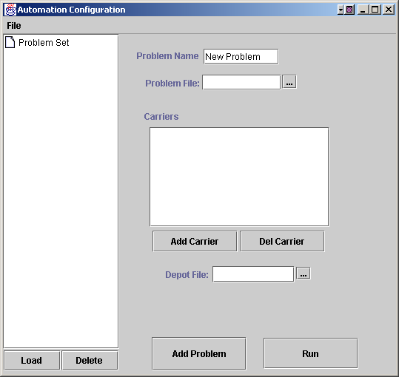
When the program is started, a screen like this will pop up. This environment has no loaded problems. So lets create a new one

Creating a New Problem Configuration
- To create a new problem configuration, first enter the name of your configuration in the “Problem Name” field. We will set this one to “Problem 1” like so:

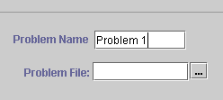
- We now need to select a Problem file. This can be done one of two ways:
  - If you know the exact name of the problem file, you can type it into the text field
  - To browse for a problem file click the button with the three dots next to the text field. This will open a file chooser, like below. The file can then be highlighted and selected using the Open button.

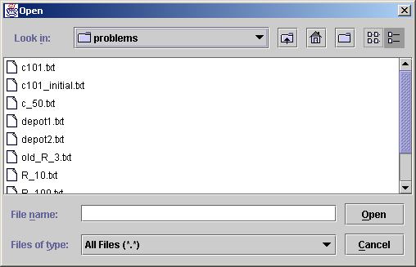

- Lets select c101.txt. This stands for a clustered assortment with 100 customers.
- Your user interface will reflect the selection of this file.

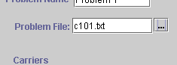
- Now we will configure the carriers. To solve a problem, at least one carrier must be started. Any number of carriers can be used however, to solve more complex problems. Lets start two carriers so they can compete with each other for the customers
- The first step in creating a carrier is to select the Depot file that will configure the carrier’s settings. This selection process works the same as selecting the Problem file. Let’s select the file “depot1.txt” for the first customer. You’re depot text field should look like this.

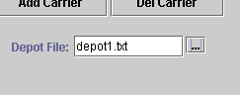

- Now this carrier can be added to the carrier list. Do this by clicking the “Add Carrier” button. The carrier’s file will now be listed in the list box under the work Carriers.

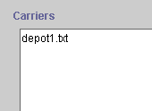

- This process can be repeated for as many carriers as needed.
- If for some reason you want to remove a carrier from the carrier list, this can be done easily by selecting the carrier from the list and clicking the “Del Carrier” button.
- To add this Problem Configuration to the problem set, click the “Add Problem” button. You will now see the problem listed in the tree on the left side of the display.

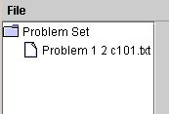

- This process can be repeated for as many Problem Configurations as you wish

Opening a Previously Saved Problem Set
- A saved Problem Set can be easily opened to be edited or run by using the File | Open menu item in the menu bar.
- Select File | Open from the menu bar.

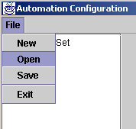

- This will start a file chooser. Select a previously saved Problem Set.

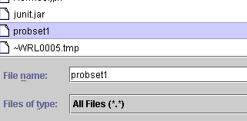

- Click the “Open” button and the Problem Set will be loaded into the interface.

Editing Existing Problems in a Problem Set
- To edit an existing problem in a Problem Set, first open the problem set if you already haven’t done so. Next select the Problem Set you would like to edit in the tree on the left side of the interface.

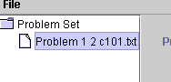

- Next Click on the “Load” button in the bottom left corner of the interface. This will load the data from this Problem Set into the text fields so that you can edit it.

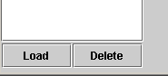

- After any changes have been made simply click the “Add Problem” button. This will update the changes to the Problem Set.



Deleting a Problem from the Problem Set
- A problem can be easily deleted by selecting it in the problem set tree and clicking the “Delete” button.

Running a Problem Set
- To run a loaded problem set. Simply click the “Run” button in the bottom right of the interface. Each problem will be solved one at a time and a solution file will be written for each.

